The Staffordshire Safer Roads Partnership (SSRP) was set up in 2001 to make a positive contribution to reducing the number of people killed and seriously injured on the roads of Staffordshire and Stoke-on-Trent.

The partnership consists of:
- Staffordshire Police
- Staffordshire County Council
- Stoke on Trent City Council
- Staffordshire Fire and Rescue Service
- National Highways

Contact Information:
Community Engagement Coordinator
Staffordshire Safer Roads Partnership
PO Box 2117 Stafford
ST16 9ZR
Phone: 01785 232702
Email: CSW@staffordshire.police.uk
Website: www.staffssaferroads.co.uk
Twitter: StaffsCSW
Facebook: Staffs Community Speed Watch

IT’S 30 FOR A REASON


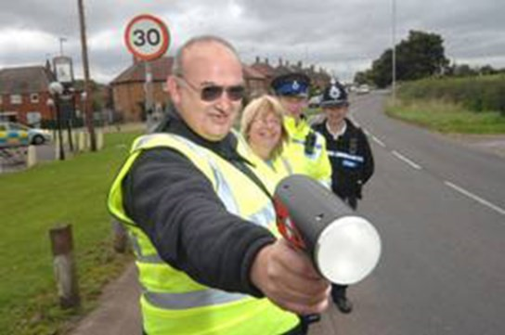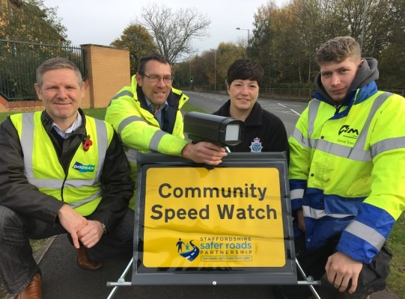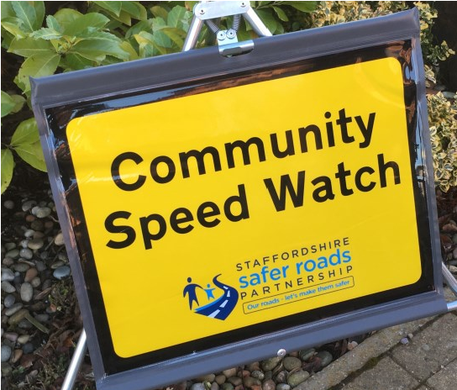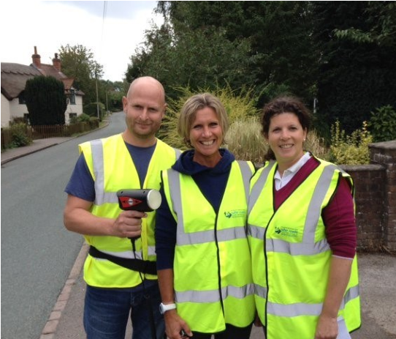

Community Speed Watch Volunteer Information
Reducing Road Casualties in
Staffordshire and Stoke-on-Trent
Community Speed Watch is an initiative whereby local residents can help make a difference in their community by helping to reduce the speed that motorists travel through their village or town.  Prior to becoming active  The volunteers will be trained by Staffordshire Police. The training will last about 2-3 hours and will cover all elements of Community Speed Watch. These include:  - Aims and Objectives of the scheme  - Conflict Management  - Health and Safety  - Operation of the Device  The scheme will identify the locations which can be used to assess the speed of vehicles and Staffordshire Police will risk assess each location to ensure the safety of the volunteers and motorists.  The scheme will be supplied with the required equipment consisting of a handheld radar device, 2 temporary signs and high visibility waistcoats.  The process  Volunteers dictate when they will go out and for how long and at which of their chosen locations they will stand. Schemes can only operate in daylight hours and cannot be operational in the rain or snow.  A minimum of 2 and maximum of 3 volunteers are out at any one time. Usually, 1 volunteer is responsible for the use of the device and identifies which vehicle is exceeding the speed limit. The other volunteer/s then enter the details of the vehicle on the log sheet. | The details required for the log sheet consist of:  - Time  - Registration Number  - Make/Model  - Colour  - Speed  To aid with the identification of vehicles each scheme is provided with a laminated sheet of car badges. If the Model of the vehicle is unknown, then the Make will suffice.  Log sheets are to be posted in the pre-paid envelopes within 24-48 hours of the volunteers conducting a speed assessment. These are then processed centrally by Staffordshire Safer Roads Partnership.  Once the vehicle details have been validated a letter is sent to the Registered Keeper warning them about the use of excessive speed. If a vehicle is detected on a second occasion as having been through any Community Speed Watch scheme within the county of Staffordshire a second more sternly worded warning letter is sent. On the third occasion if the same vehicle is identified arrangements are made for a Police Officer to visit the Registered Keeper and issue a verbal warning. Before making these arrangements we perform appropriate checks on the vehicle involved, thus ensuring that the officer has substantial information for the appropriate warning to be issued.  Medical Conditions  It is important each volunteer is fit for the role, which will include carrying equipment and standing for periods of time in various temperatures. Medical conditions must be disclosed in the Sign-up Sheet and will be assessed prior to training.

