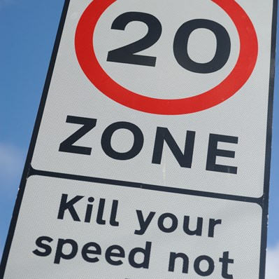
Application Pack: DFT Integrated Transport Block (ITB) Safety Scheme Funding

Glossary

Integrated Transport Block (ITB) Department for Transport funding allocated to Local Transport Authorities to facilitate enhancements to transportation networks and amenities on a smaller scale.
A "Local Transport Authority" refers to a governmental or administrative body responsible for the planning, development, regulation, and management of transportation infrastructure and services within a specific geographical area, typically at the local or regional level. These authorities are tasked with overseeing various aspects of transportation, including roads, public transit systems, cycling and pedestrian infrastructure, and other modes of transportation.
Local Transport Authority
A "Local Transport Plan" (LTP) is a strategic document developed by a Local Transport Authority (LTA) that outlines policies, objectives, and investment priorities for the improvement and management of transportation within a specific geographical area over a defined period, typically ranging from five to ten years. LTPs are designed to address the unique transportation needs and challenges of a locality, aiming to improve accessibility, reduce congestion, enhance safety, promote sustainable travel modes, and support economic growth and development.

Local Transport Plan

Approval and Review
This pack was last approved by the [Cabinet Member] on [date] by [x] and is next due for review and refresh in [x]

Introduction

Integrated Transport Block (ITB) funding is allocated to local transport authorities to enhance transport networks and amenities at a smaller scale, at local discretion; typically guided by the adopted statutory Local Transport Plan (LTP) and its accompanying policies and strategies.
Aligned with Stoke-on-Trent's overarching Transport Strategy, the ITB program serves as a vital component. This comprehensive strategy encompasses various funding channels, including allocations from the Department of Transport such as the Integrated Transport Block and Highway Maintenance block grants.
Comprising small-scale schemes in size and budget, the Integrated Transport Block program predominantly consists of routine initiatives and fund distribution follows an inclusive and collaborative approach, with program development shaped by diverse stakeholders.
Programs are structured around Stoke-on-Trent Council's overarching strategy, which revolves around six core themes: Healthier, Wealthier, Safer, Cleaner, Greener, and Fairer.
These initiatives are all framed within the broader objective of effective Asset Management and Resilience and to fulfil the council’s network management duties to keep people safe and minimise congestion.
Given the limited funding it will not always be possible to take every scheme through to construction to help explain why see the FAQ’s below

• Why can’t all bids be approved?
Not all bids can be approved due to limited funding availability and the need to prioritise projects that align most closely with the objectives and criteria set forth by the Department for Transport (DFT). Each bid undergoes rigorous assessment to ensure that approved projects deliver the greatest benefit to the community within the available budget.

• How and when are applications assessed?
The assessment process typically involves a thorough review of each application's alignment with funding priorities, feasibility, cost-effectiveness, and potential impact. The timing of assessments may vary depending on the specific funding cycle and deadlines set by the DFT.

• Who judges
The assessment and judging process may involve a combination of officers, Cabinet Members and any main stakeholders IE Blue light Services, and sometimes external experts. This ensures a comprehensive and impartial evaluation of each application based on established criteria and priorities.

• How will I find out?
Upon completion of the assessment process, applicants will be notified of the outcome through their preferred contact method indicated in their application. This could be via email, phone call, or postal mail. Applicants are encouraged to provide accurate and up-to-date contact information to ensure timely communication.

• Is there an appeal or resubmission process?
In the event that an application is not successful, there may be opportunities for appeal or resubmission, Applicants will be provided with information regarding the appeal process, including any deadlines and requirements for resubmission, in their notification of the outcome. It's important to carefully review this information and follow the provided instructions if considering an appeal or resubmission.

Dear Resident or Ward Member…
Thank you for your interest in applying for a safety scheme through the Department for Transport (DFT) Integrated Transport Block (ITB) funding. This pack contains all the necessary information and forms to help you apply for funding to support safety improvements in our community. We look forward to receiving your application and working together to create safer streets for everyone.
Steven Lovatt | Head of – Highways and Emergency Planning

Application Process Overview:

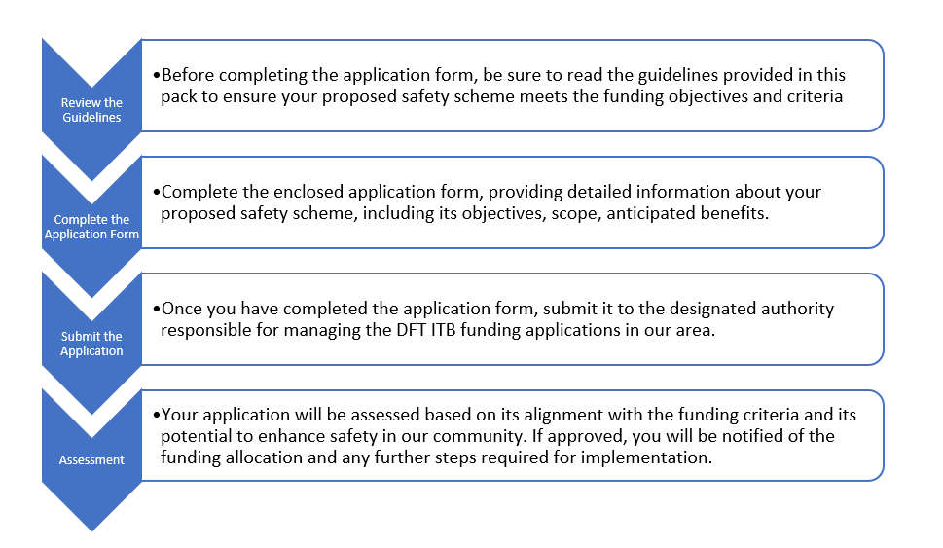

Application Pack Contents:

Guidelines: Review the guidelines to understand the eligibility criteria and requirements for the DFT ITB funding.
Contact Information: Find contact details for assistance or inquiries related to the application process.
Terms and Conditions: Read and agree to the terms and conditions governing the use of DFT ITB funding for safety schemes.
Application Form: Complete this form to apply for DFT(ITB) funding for your safety scheme project.

Guidelines
Eligibility Criteria
Bids must be submitted by residents Ward Members or community groups within the Stoke on Trent
Project Scope
Bids should propose projects that aim to improve local transport infrastructure, enhance accessibility, promote sustainable modes of transportation, or address specific transportation challenges within the community and not have a greatly increased maintenance revenue burden
Projects may include but are not limited to road improvements, cycling and pedestrian infrastructure, public transportation enhancements, traffic management measures, and initiatives to reduce carbon emissions.
Application Process
Applicants must complete the designated application form provided by the local authority responsible for administering the LTP iTb funding.
All sections of the application form must be filled out accurately and comprehensively, providing detailed information about the proposed project, its objectives, anticipated outcomes, budgetary requirements, and any supporting documentation.
Assessment Criteria
Assessment criteria may include alignment with funding priorities, feasibility, potential impact on the community, value for money, sustainability, and compliance with relevant regulations and policies.
Notification of Outcome
Applicants will be notified of the outcome of their bid through their preferred contact method as indicated in the application.
Notifications will include information regarding the status of the bid, any conditions or requirements for funding approval, and guidance on next steps.
Appeal or Resubmission Process
Applicants whose bids are not successful may have the opportunity to appeal the decision or resubmit their bid, subject to the guidelines and procedures outlined by the local authority and the DFT.
Details regarding the appeal or resubmission process, including deadlines and requirements, will be provided to applicants in their notification of the outcome.

Compliance and Reporting
Regular monitoring and evaluation may be conducted by the local authority to ensure that funded projects achieve their intended objectives and deliver value for the community.
Support and Assistance
Applicants are encouraged to seek assistance or clarification from the local authority's designated contact person or support team if they have any questions or require guidance throughout the application process.
The local authority may provide workshops, information sessions, or online resources to assist applicants in preparing their bids and understanding the requirements of the funding program.
Contact Details
Highway Asset and Intelligence management

Terms and Conditions
Eligibility
Bids must be submitted by residents or community groups residing within Stoke on Trent eligible for the Local Transport Plan (LTP) Integrated Transport Block (iTb) funding from the Department for Transport (DFT).
Applicants must adhere to the specified geographical boundaries and eligibility criteria outlined by the DFT and the local authority.
Application Process
Applicants must complete the designated application form provided by the local authority responsible for administering the LTP iTb funding.
All information provided in the application form must be accurate, complete, and in accordance with the guidelines and requirements specified by the local authority and the DFT.
Incomplete or False applications may not be considered for funding.
Project Scope and Objectives
Bids should propose projects that aim to improve local transport infrastructure, enhance accessibility, promote sustainable modes of transportation, or address specific transportation challenges within the community. Projects must align with the funding priorities and objectives set forth by the DFT and the local authority.
Assessment and Selection Process
The assessment process may include considerations such as project feasibility, anticipated outcomes, value for money, community impact, and compliance with relevant regulations and policies.
The decision to approve or reject a bid rests with the local authority, and their decision shall be final.
Funding Conditions
Funds provided under the LTP iTb funding program must be used exclusively for the purposes outlined in the approved bid and in accordance with the terms of the funding agreement.
Any deviation from the approved project scope or misuse of funds may result in the termination of funding and legal action.
Reporting and Monitoring
Successful applicants must comply with all reporting requirements specified in the funding agreement, including financial reporting, progress updates, and project evaluations.
The local authority reserves the right to conduct regular monitoring and inspections to ensure that funded projects are implemented effectively and achieve their intended outcomes.
Appeals and Disputes
Applicants have the right to appeal the decision regarding their bid in accordance with the appeals process established by the local authority.
Any disputes arising from the bidding process or the administration of the LTP iTb funding program shall be resolved through mediation or other alternative dispute resolution mechanisms as determined by the local authority.
Compliance with Laws and Regulations
Applicants must comply with all applicable laws, regulations, and statutory requirements in the preparation and implementation of their projects funded under the LTP iTb program.
The local authority reserves the right to withhold or recover funds if any breaches of legal or regulatory requirements are identified.
Amendments and Modifications
The terms and conditions outlined herein may be amended or modified by the local authority at their discretion, with any changes communicated to applicants in writing.
Applicants are encouraged to review the terms and conditions regularly for updates or changes that may affect their bids or funding arrangements.

Application Form: DFT ITB Safety Scheme Funding

Section 1: About You
Your Preferred Title:
Your Name (Resident/Ward Member):
Contact Information (Phone/Email):
Residential Address (if applicable):
Ward/Area Represented (if applicable): .
Role or Position (if Ward Member):
Organisation/Association (if applicable):

Section 2: Bid Category
What type of safety issue are you seeking to address:
Accessibility / Mobility
Child Safety at Schooltime
Cyclist Safety
Parking Problems
Pedestrian Safety
Road Congestion
Speeding
Something else (please state)

Section 3: Location
Which location(s) does the bid refer to? (which area, street or junction)

Section 4: Your perspective
Could you describe the main issue and any other relevant details, like when the issue occurs and what has changed so it is now an issue?

Section 5: Supporting Information and Evidence
What supporting information and evidence supports your bid?
I just live locally and have personal experience and am concerned about it.
I have kept a log of near misses and collisions there
I have video footage to explain the issue
I am relaying this request on behalf of a community group
There has been a serious accident there recently
Other

Section 6: Objective and Expected Benefits
Should the bid be successful, what do you think the benefits will be?
Fewer Collisions
Reduced Congestion
Safer Cycling
Safer Driving
Safer Walking
Safer for People with Mobility Issues
People are more likely to walk to local places
People are more likely to ride to local places
People with mobility issues are more likely to be able to live a fuller life.
Other

Section 7: Community Support and Engagement

If the issue is within a street or cul-de-sac what percentage of residents are supportive of the bid
How do you know?
I surveyed the residents on (enter date)
I attended a meeting with these residents on (enter date)
I canvassed residents door-to-door on (enter date)
Can you summarise the feedback?
The supportive community feedback was:

Some residents were not supportive and their reasons were:

In summary:

Other feedback?
Do you have any other information or comments regarding community engagement for or against this bid?

Other contacts?
Are you able to share the details of any other individuals who may be able to provide further evidence or support for this bid?

Section 8: Incident Log (Diary of Incidents see below )
Please provide a diary log of incidents related to safety concerns in the proposed area over a Three (3) month Period . Include details such as date, time, location, type of incident, and any relevant notes or observations.

Section 9: Declaration
By submitting this application, I confirm that the information provided is accurate and complete to the best of my knowledge. I understand that the decision regarding funding allocation is at the discretion of the designated authority and that further documentation or verification may be required.

Your Signature:
Date:

Section 10: Incident Diary
Please use this diary as a personal log of incidents you or others have witnessed.
Incident date | Incident time | Where | What happened | Signed as true record

